Epsom & Ewell F.C.
21
v
Horley Town
Saturday, 27th February 2016 – 3.00 p.m.
Good afternoon! We welcome the players, supporters and officials of Horley Town for a League match, together with today’s match officials and our own regular supporters.

We must apologise once again for the reduced programme today. The reasons for this were explained in our previous issue.

We met our opponents at The New Defence back in December when we drew 2-2. It was a strange game as we were second best in the opening 45 minutes and deservedly trailed, but picked up in the second half when Horley were reduced to ten men and conceded two penalties that Kyle Hough dispatched in his usual clinical manner, only to then concede a penalty of our own in the last five minutes. It was one of those games where both teams had reason to feel disappointed, although on balance a draw was the correct result.

We hosted the league leaders Hartley Wintney here on Tuesday and were defeated by the only goal. It was a very competitive contest and our boys pushed for an equaliser all the way, only to be frustrated by some time wasting, poor decisions and yet another sending off.

Following this match we are here once again on Tuesday when Spelthorne Sports visit. Next Saturday we travel to Chertsey Town on Saturday week before returning here seven days later for matches with Knaphill and Cove in quick succession. Additionally, our postponed match at AFC Hayes has now been rescheduled for Tuesday 12th April.

There are many games to catch up before the season ends, so please keep in touch with the website, which will contain as much information as we are able to supply under the circumstances.

Please note that there are plenty of matches still available to be sponsored and many players too. All contributions help your club.

The Programme Team

Keep up with us on Facebook www.facebook.com/epsomandewellfc and on Twitter @EEFCOfficial

Cover Photos by Gemma Jarman

- James Taylor scores our first equaliser in the 2-2 draw at home in August 2014

- Tom Neale rounds the keeper to score our recent winner against Bedfont Sports

Cherry Red Records Combined Counties League
Premier Division Table 2015/16
inc Tuesday 23rd February | P | W | D | L | F | A | Pts | GD | H | A
Hartley Wintney | 27 | 23 | 2 | 2 | 82 | 23 | 71 | +59 | 0-1 | 3-3
Ashford Town (Mx) | 29 | 21 | 2 | 6 | 78 | 38 | 65 | +40 | 30/4 | 3-2
Epsom & Ewell | 27 | 16 | 8 | 3 | 60 | 24 | 56 | +36 | X | X
Camberley Town | 25 | 17 | 5 | 3 | 50 | 21 | 56 | +29 | 16/4 | 1-1
Hanworth Villa | 27 | 15 | 3 | 9 | 52 | 38 | 48 | +14 | 5-0 | 23/4
Horley Town | 26 | 14 | 5 | 7 | 63 | 35 | 47 | +28 | 27/2 | 2-2
Colliers Wood United | 32 | 14 | 4 | 14 | 64 | 56 | 46 | +8 | 3-1 | 3-0
Spelthorne Sports | 29 | 11 | 8 | 10 | 53 | 56 | 41 | -3 | 1/3 | 6-2
Raynes Park Vale | 27 | 12 | 2 | 13 | 53 | 53 | 38 | 0 | 3-1 | 28/3
Windsor | 28 | 10 | 8 | 10 | 50 | 54 | 38 | -4 | 2-2 | 1-2
Guildford City | 29 | 10 | 6 | 13 | 55 | 64 | 36 | -9 | 4-0 | 2/4
Knaphill | 22 | 11 | 2 | 9 | 46 | 35 | 35 | +11 | 12/3 | 1-1
Badshot Lea | 27 | 11 | 1 | 15 | 41 | 69 | 34 | -28 | 9/4 | 1-0
Sutton Common Rovers | 27 | 10 | 3 | 14 | 48 | 56 | 33 | -8 | 3-1 | 2-1
AFC Hayes | 29 | 9 | 6 | 14 | 41 | 55 | 33 | -14 | 1-1 | 12/4
Farnham Town | 23 | 9 | 4 | 10 | 42 | 36 | 31 | +6 | 1-0 | 22/3
Bedfont Sports | 27 | 7 | 8 | 12 | 35 | 39 | 29 | -4 | 1-0 | 2-2
Chertsey Town | 28 | 8 | 5 | 15 | 39 | 51 | 29 | -12 | 0-1 | 5/3
Westfield | 22 | 7 | 6 | 9 | 26 | 35 | 27 | -9 | 26/3 | 0-0
Chessington & Hook | 26 | 7 | 2 | 17 | 42 | 67 | 23 | -25 | 1-0 | 19/3
Redhill | 22 | 3 | 3 | 16 | 27 | 56 | 12 | -29 | 3-0 | 1-0
Cove | 26 | 1 | 1 | 24 | 18 | 102 | 4 | -84 | 15/3 | 7-0

Lucky Day? – 27th February
Played 13 - W 5 D 1 L 7 - F 20 A 20 - PPG 1.23 - Below Average
Our Club record against today’s visitors
Played 27 - W 19 D 5 L 3 - F 59 A 26 - PPG 2.30 - Fantastic
Largest wins and losses against today’s visitors
24th October 2009 - (A) W 6-0 - League - 18th February 2012 - (H) L 1-3 - League
Their Last visit
Monday 25th August 2014 - D 2-2 - Combined Counties League

First Eleven Appearances - (max 32 – including Hartley Wintney – 23/02/16)
Name | Debut | 2015/16 |  |  |  | Career Totals
 |  | App | Sub | Total | Goals | App | Sub | Total | Goals
AJAYI Tayo* | 22/08/2015 | 0 | 2 | 2 | 0 | 0 | 2 | 2 | 0
COOPER-SMITH Daryl | 03/01/2015 | 15 | 4 | 19 | 8 | 24 | 7 | 31 | 14
CURRIE Sam | 04/08/2012 | 16 | 2 | 18 | 1 | 124 | 11 | 135 | 3
DAVISON Conor* | 22/08/2015 | 1 | 2 | 3 | 0 | 1 | 2 | 3 | 0
DEAN Dan | 02/08/2014 | 22 | 2 | 24 | 0 | 58 | 3 | 61 | 0
DOWNS Carl | 17/09/2011 | 5 | 1 | 6 | 0 | 99 | 14 | 113 | 2
EACOTT Michael | 02/08/2014 | 28 | 0 | 28 | 0 | 74 | 0 | 74 | 0
FARRELL Matt | 02/08/2014 | 31 | 0 | 31 | 5 | 72 | 3 | 75 | 12
FERDINANDO Matt | 20/09/2014 | 21 | 1 | 22 | 6 | 48 | 5 | 53 | 12
GRAHAM Bentley | 09/02/2016 | 3 | 0 | 3 | 0 | 3 | 0 | 3 | 0
GRIFFIN Reisse | 08/08/2015 | 14 | 5 | 19 | 1 | 14 | 5 | 19 | 1
HASTINGS Craig | 08/08/2015 | 25 | 3 | 28 | 0 | 25 | 3 | 28 | 0
HATFIELD Jamie | 11/11/2006 | 1 | 0 | 1 | 0 | 249 | 13 | 262 | 6
HENDRY Rob | 08/08/2015 | 25 | 5 | 30 | 10 | 25 | 5 | 30 | 10
HOUGH Kyle | 14/08/2007 | 23 | 3 | 26 | 18 | 319 | 18 | 337 | 189
JONES Adrian | 06/08/2011 | 3 | 1 | 4 | 0 | 23 | 1 | 24 | 0
KURDZIEL Jakub* | 29/08/2015 | 1 | 0 | 1 | 0 | 1 | 0 | 1 | 0
MARVELL Dale* | 15/01/2000 | 8 | 4 | 12 | 1 | 269 | 49 | 318 | 86
McGREGOR Alex* | 08/08/2009 | 7 | 3 | 10 | 2 | 179 | 59 | 238 | 29
MCKAY Alex | 20/12/2008 | 22 | 1 | 23 | 0 | 107 | 27 | 134 | 8
NEALE Thomas | 13/10/2015 | 11 | 9 | 20 | 6 | 11 | 9 | 20 | 6
NEILL David* | 03/10/2015 | 1 | 1 | 2 | 0 | 1 | 1 | 2 | 0
NORTH Rhys | 16/08/2015 | 13 | 7 | 20 | 0 | 13 | 7 | 20 | 0
OLIVER Beckett | 29/08/2015 | 5 | 11 | 16 | 0 | 5 | 11 | 16 | 0
PANAYIOTOU Savvas | 03/01/2015 | 6 | 3 | 9 | 1 | 22 | 6 | 28 | 4
ROBINSON Sam | 22/10/2011 | 0 | 1 | 1 | 0 | 54 | 5 | 59 | 13
ROWE Steve | 27/08/2011 | 0 | 1 | 1 | 0 | 24 | 3 | 27 | 0
SMITH Matt | 08/08/2009 | 0 | 0 | 0 | 0 | 91 | 43 | 134 | 10
TANTON Matt | 02/08/2014 | 26 | 0 | 26 | 0 | 44 | 4 | 48 | 1
TAYLOR James | 26/08/2013 | 18 | 3 | 21 | 2 | 74 | 11 | 85 | 5
THOMPSON Elliott | 09/02/2016 | 1 | 2 | 3 | 0 | 1 | 2 | 3 | 0
Own Goal |  |  |  |  |  |  |  |  | 1
* Player has left the club

Latest Results and Fixtures
Surrey Senior Cup QF – Tuesday 23rd February
Knaphill | 0-1 | Sutton United
Played at Sutton United
Combined Counties League – Tuesday 23rd February
Badshot Lea | 1-0 | Westfield
Cove | 3-3 | Spelthorne Sports
Epsom & Ewell | 0-1 | Hartley Wintney
Farnham Town | p-p | Camberley Town
Redhill | p-p | Chessington & Hook United
Combined Counties League – Friday 26th February
Colliers Wood United | V | Sutton Common Rovers
Combined Counties League – Saturday 27th February
Badshot Lea | V | Raynes Park Vale
Bedfont Sports | V | Redhill
Chessington & Hook United | V | Camberley Town
Cove | V | AFC Hayes
Epsom & Ewell | V | Horley Town
Farnham Town | V | Hartley Wintney
Guildford City | V | Windsor
Hanworth Villa | V | Ashford Town (Mx)
Spelthorne Sports | V | Chertsey Town
Westfield | V | Knaphill
Combined Counties League Cup QF – Tuesday 1st March
Camberley Town | V | Colliers Wood United
Chessington & Hook United | V | Ashford Town (Mx)
Cobham | V | Westfield
Knaphill | V | Farnham Town
Combined Counties League – Tuesday 1st March
AFC Hayes | V | Badshot Lea
Bedfont Sports | V | Cove
Epsom & Ewell | V | Spelthorne Sports
Hanworth Villa | V | Sutton Common Rovers
Redhill | V | Guildford City

From behind the goal
Epsom & Ewell 0-1 Hartley Wintney
Combined Counties League – Premier Division – Tuesday 23rd February 2016

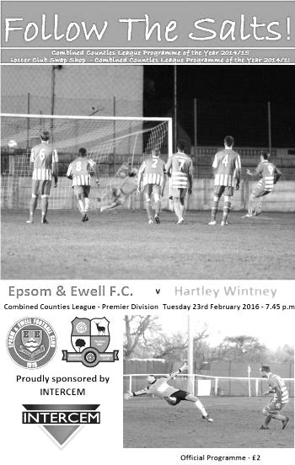
Leaders claim the points

A feisty and competitive encounter at High Road ended with a single goal victory for league leading Hartley Wintney and a frustrating evening for all concerned with Epsom and Ewell.

The first half possession went in favour of the visitors, although with not too much to show for it until they took the lead after 24 minutes when a low left wing cross was not gathered by Michael Eacott and the loose ball fell straight to Adam Everiss who had no difficulty in knocking the ball past the two covering defenders on the line and into the net. We responded well with Matt Ferdinando firing for the top corner but his shot was well tipped over by the excellent Craig Atkinson in the Hartley goal.

He was just wide with a free kick just before half time and we pushed for an equaliser, but on a night where there were some very erratic decisions by the referee, Ferdinando was upended and when the free kick wasn't awarded, he got involved with the visitors Joe Paris, who ended up on the floor. He was then sent off and Epsom's Assistant Manager Matt Smith then followed him.

The game deteriorated further with both sets of players appealing for everything against an official that had lost control of the game and even the introduction of strikers Kyle Hough and Rob Hendry was unable to retrieve a draw. All in all though it was a very competitive game and a very large step for the visitors as they extended their lead at the top of the table.

Team: Michael Eacott, Rhys North, Matt Tanton, James Taylor,
Craig Hastings, Bentley Graham, S.Panayiotou, Matt Farrell (c),
Tom Neale, E.Thompson, Matt Ferdinando

Subs: Kyle Hough for Thompson (66), Rob Hendry for North (78)

Horley Town – History
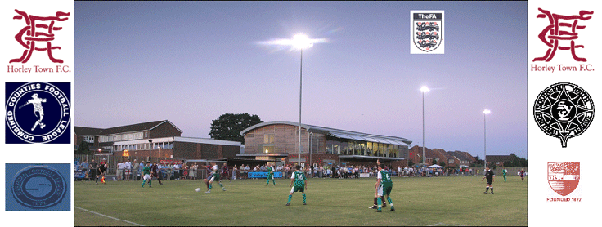
Horley Town Football Club were founded in 1898 to provide football for the local community. From its early days the aim has not changed, it still provides for healthy competition from boys and girls aged seven through to senior status. From junior football there has always been a team capable of competing in whatever league it was playing in. The club progressed from junior football for its first team to intermediate and eventually on to senior status. At senior level the club were members of the Surrey Senior League and progressed to the old Spartan League in 1979. From here after winning the league, the club progressed in 1981 to the old Athenian League.

After a few years in the doldrums the management committee decided, with the full backing of the members to take stock of where the club was and in 1997 it was decided to go back to junior football in the Crawley and District League, thus allowing a chance to bring on a crop of outstanding youngsters through to the senior team, and the majority of whom are still with the club today.

A successful year in 2001 saw the first team win the Crawley League and Charity Cup, which led the management committee to decide that with the youth set up in place it was now the right time to return to senior football, and were promoted to the Surrey Senior League. From here the club was then accepted into the Combined Counties League in 2002.

During this time the club also moved into its new state of the art ground called The New Defence and it is with thanks to past and present management committee members that this has been possible as without all their hard work behind and in front of the scenes this could never have been achieved, and is something we can all be proud of.

On Sundays, Horley Town has no less than 26 teams competing in various leagues from under 7 to under 17 and this has and always will be the way forward for us, bringing through our own talent and providing for the future. Horley Town also boast 2 senior ladies teams. We are lucky to have committed managers and players within our junior set up that make this happen, and our thanks go out to them.

The club has a committed five-year programme to provide facilities capable of entering the very best football competitions outside of the football league, and with the New Defence it only bodes well for the future of such an old established club. On the social front the membership amounts to over 450 many of these with family memberships, swelling the numbers considerably.

In 2013/14 Horley escaped relegation on the final day of the season when drawing 4-4 with Mole Valley SCR. The following season looked like they would face a similar battle but a strong finish to the season enabled them to get out of trouble and they have kept that momentum into the 2015/16 season where they sit in a very healthy position.

Player Profile – Number 14 – Matt Farrell
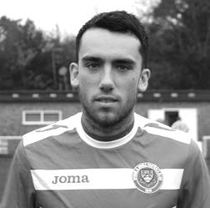
Our latest profile is from our current Captain, the ever hard – working Matt Farrell.

Age: 26

Position: Midfield

Club supported: Arsenal

Favourite Food: Lamb Roast

Favourite Film: Bourne Identity / Snatch

Messi or Ronaldo: Messi

Favourite Drink: Tea

Favourite Ground played on to date: Surbiton Town!!

Best moment for the club: Scoring on my debut at Farnham Town

Describe the Gaffa in three words: Big – Huggy – Bear

Centre page for results

Centre page for results

Player Sponsorship
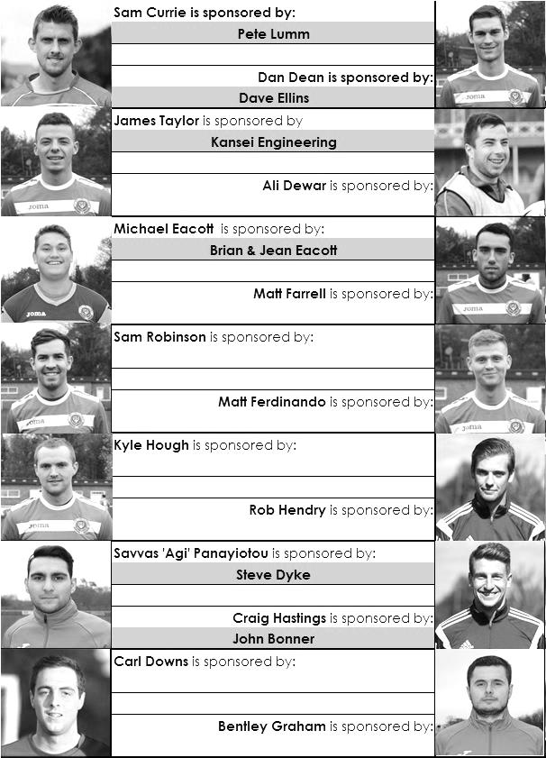

Here is the current list for the 2015/16 season showing all of our players and Management that are currently available for sponsorship this season.

Sponsorship costs just £40 and it is easy to do. Just select a player who has not been previously sponsored and let a Committee Member know that you would like to sponsor them. Beware though. Until we have received the money it is possible for someone to jump in front of you, so don’t delay, sponsor today!
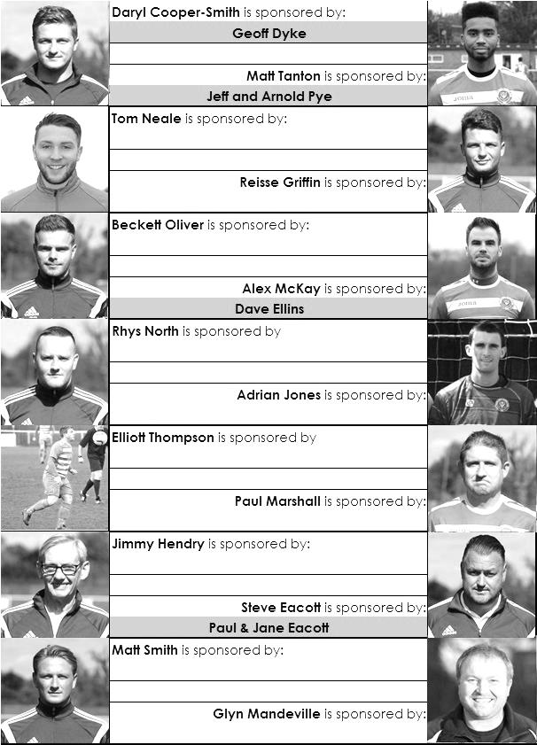

CCL Premier Division Club Directory
A.F.C. HAYES Telephone: 0208-845-0110 - Ground: Farm Park, Kingshill Avenue, Hayes, Middx. UB4 8DD - Colours: Blue and White Stripes/Blue/Blue

ASHFORD TOWN (Mx) Telephone: 01784-245908 - Ground: The Robert Parker Stadium, Short Lane, Stanwell, Middx. TW19 7BH - Colours: Tangerine & White Stripes/Black/Tangerine

BADSHOT LEA Telephone: 01252-320385 - Ground: Ash United FC, Shawfield Stadium, Youngs Drive, Shawfields Road, Ash, Hampshire. GU12 6RE - Colours: Claret/White/Claret

BEDFONT SPORTS Telephone: 0208-831-9067 - Ground: Bedfont Sports Club, Hatton Road, Bedfont, Middx TW14 8JA - Colours: Red & Black Hoops/Black/Red & Black Hoops

CAMBERLEY TOWN Telephone: 01276-65392 - Ground: Krooner Park, Wilton Road, Camberley, Surrey. GU15 2QW - Colours: Red & White Stripes/Blue/Red

CHERTSEY TOWN Telephone: 01932-561774 - Ground: Alwyns Lane, Chertsey, Surrey. KT16 9DW - Colours: Royal Blue & White Stripes/Royal Blue/Royal Blue

CHESSINGTON & HOOK UNITED Telephone: 01372-602263 - Ground: Chalky Lane, Chessington, Surrey. KT9 2NF - Colours: Blue/Blue/Blue

COLLIERS WOOD UNITED Telephone: 0208-942 8062 - Ground: Wibbandune Sports Ground, Robin Hood Way, Wimbledon. SW20 0AA - Colours: Blue & Black Stripes/Black/Black

COVE Telephone: 01252-543615 - Ground: Oak Farm Fields, 7 Squirrel Lane, Cove, Farnborough, Hampshire. GU14 8PB - Colours: Yellow/Black/Yellow

EPSOM & EWELL Telephone: 01737-553250 - Ground: Chipstead FC, High Road, Chipstead, Surrey. CR5 3SF - Colours: Royal Blue & White Hoops/Royal Blue/Royal Blue & White Hoops

FARNHAM TOWN Telephone: 01252-715305 Ground: Memorial Ground, Babbs Mead, West Street, Farnham, Surrey. GU9 7DY Colours: - Claret & Sky Blue /White/ Claret & Sky Blue

GUILDFORD CITY Telephone: 01483-443322 - Ground: The Spectrum, Parkway, Guildford, Surrey. GU1 1UP - Colours: Red & White Stripes/Black/Black

HANWORTH VILLA Telephone: 0208-831-9391 - Ground: Rectory Meadows, Park Road, off Hounslow Road, Hanworth, Middlesex. TW13 6PN - Colours: Red & White Stripes/Black/Black

HARTLEY WINTNEY Telephone: 01252-843586 - Ground: Memorial Playing Fields, Green Lane, Hartley Wintney, Hants RG27 8DL - Colours: Orange & Black/ Orange /Orange

HORLEY TOWN Telephone: 01293-822000 - Ground: The New Defence, Anderson Way, Court Lodge Road, Horley, Surrey. RH6 8SP - Colours: Claret & Sky Blue/Claret/Claret

KNAPHILL Telephone: 01483-475150 - Ground: Brookwood Country Park, Redding Way, Lower Guildford Road, Knaphill, Surrey. GU21 2AY - Colours: Red/Black/Red

SUTTON COMMON ROVERS Telephone: 01932-866386 - Ground: Sutton United FC, Gander Green Lane, Sutton, Surrey SM1 2EY - Colours: Yellow/Black/Black

RAYNES PARK VALE Telephone: 020-8540-8843 - Ground: Prince Georges Playing Field, Grand Drive, Raynes Park, London. SW20 9NB - Colours: Blue/Blue/Red

REDHILL Telephone: 01737-762129 - Ground: Kiln Brow, Three Arch Road, Redhill, Surrey RH1 5AG - Colours: Red and White Stripes/Black/Red

SPELTHORNE SPORTS Telephone: 01932-961055 - Ground: Spelthorne Sports Club, 296 Staines Road, Ashford Common, Ashford, Middx. TW15 1RY - Colours: Light & Dark Blue/Dark Blue/Light Blue

WESTFIELD Telephone: 01483-771106 - Ground: Woking Park, Kingfield Road, Woking, Surrey. GU22 9BA - Colours: Yellow/Black/Black

WINDSOR Telephone: 01753-860656 - Ground: Stag Meadow, St Leonards Road, Windsor, Berks SL4 3DR - Colours: Red/Red/Red

Match and Ball Sponsorships – 2015/16
Opponent | Date | Match Sponsor | Match Ball Sponsor
Hoddesdon Town | 18/07/15 | Geoff Dyke
Windsor | 08/08/15 | Club President - Stella Lamont
Erith & Belvedere (FAC) | 16/08/15 | Committee Member - Mike Lovett
Raynes Park Vale | 31/08/15 | EEFC Management Committee
Colliers Wood United | 08/09/15 | Bookham Building Shop – www.buildingshop.co.uk
AFC Hayes | 19/09/15 | John Bonner
Farnham Town | 26/09/15 | Ezara and Inaya Beddoe – our youngest supporters!
Chertsey Town | 17/10/15 | Club Media Officer – Richard Lambert
Dorking Wanderers (SSC) | 20/10/15 | Tony Ferdinando
Chessington & Hook United | 07/11/15 | Paul Merritt
Hanworth Villa | 21/11/15 | Maggie Beddoe
Guildford City | 05/12/15 | Pete Lumm
Sutton Common Rovers | 19/12/15 | Marvin Hough
Ashford Town (Mx) (LC) | 12/01/16 | Pete Beddoe & Steve Dyke
Redhill | 02/02/16 | David Lawton
Bedfont Sports | 13/02/16 | Bookham Building Shop – www.buildingshop.co.uk
Hartley Wintney | 23/02/16
Horley Town | 27/02/16
Spelthorne Sports | 01/03/16 | In memory of Chris Henry
Knaphill | 12/03/16
Cove | 15/03/16
Westfield | 26/03/16 | Nathan Lambert
Badshot Lea | 09/04/16
Camberley Town | 16/04/16
Ashford Town (Mx) | 30/04/16 | Club President - Stella Lamont
Ashford Town (Mx) | 30/04/16 | Brian Eacott | Steve Dyke
For League, League Cup and Surrey Senior Cup Matches:
Match sponsorship - £40.00 Match ball sponsorship - £25.00. Combined £55.00.
For F.A. Cup and F.A. Vase matches:
Match sponsorship - £50.00 Match ball sponsorship - £30.00. Combined £65.00.

Sponsorship includes: ( x2 for match, x3 for match and ball )

Admission, programmes, hospitality, advertising and mascot for the day (if required ).
If you are interested, just speak to a Committee Member, or drop me an email at: richard.c.lambert@gmail.com

We also thank our Kit Sponsors INTERCEM

Combined Counties League – Premier Division
Saturday, 27th February 2016 - Kick-off 3.00 p.m.
Epsom and Ewell  (Royal Blue & White hoops) | V |  | Horley Town  (Claret & Blue)
Squad | NUMBERS |  | Squad
Michael Eacott |  |  | George Hyde
Rhys North |  |  | Liam Cox
Matt Tanton |  |  | Jack Poplett
James Taylor |  |  | John Eldred
Craig Hastings |  |  | Adam Pullin ©
Bentley Graham |  |  | Lewis Forsdick
Savvas ‘Agi’ Panayiotou |  |  | Scott Robson
© Matt Farrell |  |  | Ben Herdman
Tom Neale |  |  | Ashley Nadesan
Elliott Thompson |  |  | James Clarke
Matt Ferdinando |  |  | Connor Power
Kyle Hough |  |  | Justin Ford
Reisse Griffin |  |  | Bailey Rumbelow
Sam Robinson |  |  | Liam Giles
Rob Hendry |  |  | Asa Curtis
Alex McKay |  |  | Leyton Regan
Adrian Jones |  |  | Michael Smith
Sam Currie |  |  | Robert Burbidge
Beckett Oliver |  |  | Ryan Brackpool
Carl Downs |  |  | Richard Wetton
Dan Dean |  |  | Nathan Jupp
Glyn Mandeville | MANAGER |  | Anthony Jupp
Matt Smith | ASSISTANT
Steve Eacott / Alex McKay / Jimmy Hendry | COACHES / PHYSIO
REFEREE: S.Farrer (Reigate)
ASSISTANTS: R.Hailstone (Aldershot), R.Van Niekerk (Sutton)

OUR NEXT VISITORS TO HIGH ROAD ARE:
Spelthorne Sports

Tuesday 1st March 2016 - Kick-off 7.45 p.m.
Combined Counties League – Premier Division

